PARISH NEWS
The Deverills & Crockerton

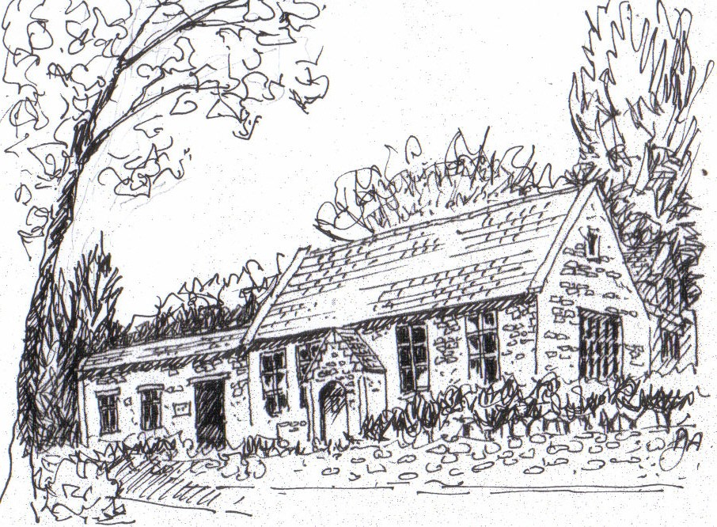

Crockerton School
by Pat Armstrong

September 2008

Look inside for local information

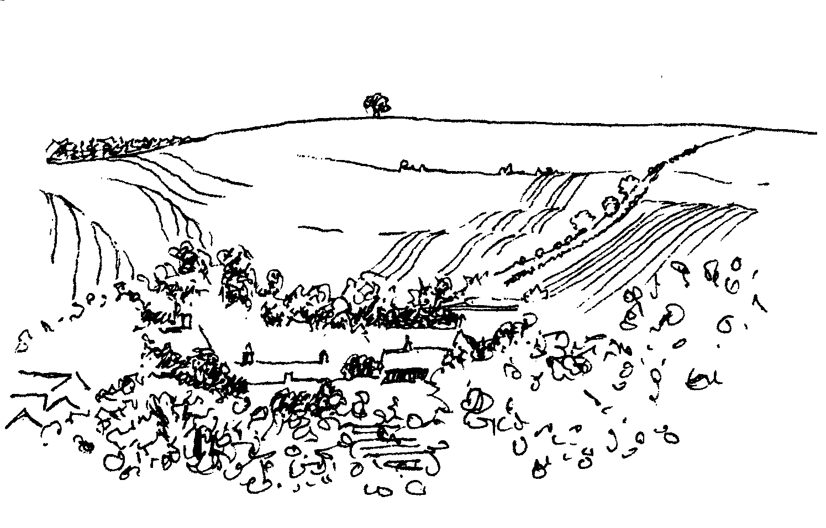
-2-

Music in the Deverills
4+1 Jazz Band - leader Bob Jones
New Orleans and Dixieland Jazz
8.00 pm Friday 12th September in Brixton Church
Tickets £10 (inc glass wine) in advance from Mary Stewart Cox 840877
Pre-concert supper 6.30 pm
At Brixton Manor House by kind permission of Johnny & Pony Burridge
Tickets £8 per head in advance from Mary Stewart Cox 840877
All profits to the Deverill Valley Churches Fabric Fund (Bring a cushion!)

SATURDAY 13TH SEPTEMBER

SUPPORT THE WILTSHIRE

HISTORIC CHURCHES TRUST

TO TAKE PART

PLEASE CONTACT

JUDY MUNRO 844385


Christian Aid Big Tea Party
Friday 19th September
4.00 pm
Longbridge Deverill Village Hall
Please come and join in the fun to support Christian Aid

Cream Teas and Open Garden in aid of Save the Children
Mill Farm House, Hill Deverill
Sunday 28th September

Cakes, plants and other interesting items for sale
Enjoy a relaxing afternoon in the barn or garden

-3-

The Curate of the Benefice of Cleyhill Villages writes:
I am delighted to have this opportunity to thank everyone in the Benefice for their prayers and support over the four years of my training. Last year I was ordained as a Deacon and on 28th June, this year, as a priest. ‘Why be ordained again?’ many have asked. To put it in its simplest form, ordination in the Anglican Church is an ‘appointment’ by the Bishop. In my first ordination I was appointed to be a deacon and, in the second, as a priest. However, ordination as priest does not nullify the appointment as deacon. On the contrary, once a deacon always a deacon, even if called and appointed to become a Bishop!
Being a deacon is about serving; it is the incarnational role of walking, living, praying and worshipping with the people you are called to serve. In practical ways this includes visiting the sick and housebound, giving home communion to those who cannot come to church, visiting new families, those who have been baptised and the families who have suffered bereavement. It involves enabling and encouraging others to share in this ministry. Through our baptism we are called to use the gifts given to each one of us by God to spread the Good News of the gospel of Christ.
During the past nine months, I have done many of these things as well as assisting Norma by taking weekly services, preaching and teaching. It was also a time just to ‘be’ and observe the life of a priest, to soak up some of atmosphere in readiness for this ministry.
None of this will change but more will be added! For me it is the fulfilment of my calling. As a priest I am able to administer the sacraments, preside at the Eucharist service, take baptisms and weddings. A priest may anoint, hear confessions and give absolution in the name of Almighty God.
My calling to serve God in this community came some years ago, while supporting another Ordinand in training. I have approached the training year by year and, with each new step, I have been richly rewarded by all that it offered. However, I have not made this journey alone. Ordained Local ministry is about being called out by the community to serve God in that place. It is a partnership upheld in prayer and one that I pray will continue as we journey together over the years to come.

Di Britten
Sponsored Ride and Stride 25th Anniversary
Please take part or sponsor someone on Saturday 13th September in the Ride and Stride which is the Wiltshire Historic Churches Trust’s annual fund raising event. The Trust provides grants to help maintain many beautiful churches in our county. It would be wonderful if we could exceed the amazing total raised in our parish last year of £756.50 to celebrate the 25th Anniversary. Please get involved and contact me for sponsor forms and further information.
Judy Munro 844385

-4-

Macmillan Cancer Support
World’s Biggest Coffee Morning
Crockerton Garden Centre
Friday 26th September
10.00 am till 12.00 noon
For any further information contact Janet Budgen 218203



Fight for Sight Fair
10.00 am - 3.30 pm Thursday 2nd October
We are coming back to the Deverills!
Our new venue is the Rye Hill Barn
(on the road from Longbridge to Maiden Bradley)
Lots of new stallholders
All your Christmas shopping in one go
Meet friends for a delicious lunch or snack made by Sandy Parrish



Mere Literary Festival 13th - 19th October
Mere Literary Festival opens as usual on the second Monday of October and the organisers have again lined up an eclectic programme at affordable prices. Authors appearing include Ruth Waterman, Justin Pollard, Adrian Tinniswood, Malcolm Welshman, Richard Hallows, Michael Dobbs, Liz Jones, John Harris, Rex Sawyer and Marion Molteno. There is a reminiscence afternoon, a Diary Day, a writing workshop, film, live theatre and words and music from organist David Power recounting A Powerful Journey. You can enter a team in the popular Literary Quiz with a chance to win The Lawrence Shield or Jeanette Francis Cup. Results of the festival’s short story competition are announced at the Award Ceremony on its final day. You don’t need to be an entrant to come along to hear the adjudications or browse the bookstalls. For full details and booking pick up a big green programme or log on to www.merelitfest.co.uk Tickets are available at a Mere TIC/Library, by post with the booking form or Tel: 01747 860475. Proceeds of the festival support the Mere & District LinkScheme (Reg.Charity No: 1062328)
Brian Fear
Carol, Tim, Helen and Stephanie wish to thank all friends in the Deverills and around who sent flowers, cards and letters. You gave us such support, love and sympathy during and after our troubled times of Brian’s illness, and later his death. To all who, for that special day, kindly decorated the church so beautifully and attended his funeral service. With your help and prayers, we felt the love, compassion and peace were getting us through these difficult times, when we are all missing Brian so very much. From the bottom of our hearts, we thank you.

-5-

Memories of Brian Fear’s life in Kingston Deverill.
Brian was born in 1934 and went to school at Kingston Deverill where he met Carol who later became his wife. They had two children, Tim and Helen. At 15½ Brian joined Manor Farm and worked his way up to become a main tractor driver; David Stratton has vivid memories of Brian driving a Massey-Harris 6 cylinder tractor (75 hp), when going flat out it sounded like a rocket and so it was nicknamed The Jet - we all know why with Brian at the wheel! He primarily used this tractor for drilling the corn, haymaking and pulling the muck cart. He was also one of three combine drivers; he was always in the lead and out of sight because he would have the engine going flat out! Once at Zeals he took a short cut getting stuck in wet ground and later in a convoy he put his combine in the ditch at Kilmington - this was someone else’s fault for letting the lorry overtake!
Brian was 45 years old when I came to Kingston in 1979; by then he was driving a larger combine. He had also moved on to building maintenance and house renovations. This included plumbing - he revelled in mud and water. He was now in his element, and with his attitude of make it or mend it he was invaluable. Painting took up a lot of his time - Magnolia was a favorite but the more garish the colour the better! He had various redundant buildings around the farm where he kept his treasures and supplies - nothing was allowed to be thrown away. He was not one for helping with the livestock unless there was trouble, a milking cow in the parlour pit or a cow stuck in the cubicles - call for Brian. Once he helped extract a heifer from an open septic tank in someone’s garden - he loved it! One winter’s day Dee Barn was cut off by snow, Brian steered the Land Rover through a white-out to the exact spot in the middle of a field to find the stopcock we were looking for. I never knew where Brian was during a working day, in Wincanton, Gillingham or Warminster or just two jobs ahead of me? He never answered his two-way radio! At home he turned wood, did carpentry, clock building (water or mechanical), made corn dollies and loved his garden. He was a country man; he knew the seasons and country life.
The lasting impression of Brian to people in the village was his smile. His energy knew no bounds and he was fearless. Whatever job he was asked to do, before you had finished explaining it, he had started and probably finished it! Problem solving was his strength. He was conscientious, nothing was too much bother and he never held a grudge against anyone. After he retired he created a new job of looking after those he could help. He was a friend to all and welcome in every house; in many of the Kingston houses he had fitted a new fireplace, floor or just a tap washer. His support to those moving into Kingston has always been appreciated, as was all the help he gave Molly Walker and many others in the village. Finally, a quote from someone who contributed to the ‘Memories of Brian’ “Any job that needed doing was done with great speed and no fuss – he was always happy to help. He liked a chat and cup of coffee afterwards. He had knowledge and skills which few would be able to match. He was full of common sense and practical advice. Always a cheery ‘Hello’ and a good friend to us all.”
Peter Smith (extract from eulogy at Brian’s funeral on Tuesday 29th July)

-6-
Salisbury Theatre Club Trips
Monday 22nd September
Drowning on Dry Land by Alan Ayckbourn
Monday 20th October
A Taste of Honey by Shelagh Delaney
Monday 17th November
A Month in the Country by Philip Wilson
The cost is £17.00: theatre seat £12.00 and coach trip £5.00
Booking and payment in advance to Mary Stewart Cox Tel 840877
Longmead, Brixton Deverill, Warminster BA12 7EJ
Coach leaves Kingston Church 6.10 pm collects through the Deverills
Performances begin at 7.30 pm

Longbridge Deverill Village Hall

Quiz Night
Friday 26th September 7.30 pm for 8.00 pm
Chilli - Jacket potato - Bar
Tickets £6 from Sylvia Titt 214825
Bring your friends and make up a table of 6 people
You could win the ‘magnificent’ Village Hall Quiz Cup and Prizes!

CROCKERTON MILLENNIUM COMMITTEE
THE DUCK RACE
SUNDAY 28TH SEPTEMBER
1st prize £50, 2nd prize £25, 3rd prize £10
Ducks for sale at £1
Contact: Marion 213739, Tracey 216939,Trish Matthews 846613

Yoga Classes with Olivia and Daniel
At The Old Pottery, Bull Mill, Crockerton
Starting week beginning 8th September
Tuesday 7.00 - 8.30pm, Wednesday 9.30 -11.00 am
Thursday 6.30 - 8.00 pm
To book and for details, please call 212716

-7-

Upper Deverills Village Hall
Future Events
Please note of the following dates, more details in the October Parish News:
Eddie Mirzoeff Film Night on Friday 3rd October
Harvest Supper on Saturday 18th October
Upper Deverills Fete, Flower & Dog Show
I had the responsibility with Richard Joy of collecting ‘goodies’ for the Tombola. The response in Kingston Deverill was just amazing. People were so generous with both goods and money. I put some of the money given towards baking materials for the scones to be sold at the Fete. Thank you to those who donated cash. It was an interesting evening collecting as Phil, my chauffer, took me to houses in the village I never knew existed, so it was a good opportunity to meet people and make some new friends.
For those of you that are not aware Phil, my husband, is your local Bobby. He gave his time and then attended the Fete in his working capacity as a Police Officer, showing his vehicle off and the gadgets he has to carry and uses in a day’s work, keeping Wiltshire safe. He was delighted with the welcome he received by young and old alike. His job can be a very difficult and frustrating one at times often working long days and nights, twelve hours is not unknown. Phil was very pleased so many of you were able to stop and chat. However, the icing on the cake was how many people told him he is making a difference. Everyone needs to hear that now and again, it makes a refreshing change from the criticism and complaints that can so often burden a police officer. Thank you all once again and give your village Bobby a wave and a smile as he drives by.
Dizzy Bridge
N B This year a profit of about £600 was made, thank you to all who made this such a successful afternoon.
Deverills Cricket Club
The season concludes with hopefully better weather. If you would like find out about joining the Club come to our next match or you can contact Peter Child on 01963 34593 or Jamie Fagan on 01985 844123 who will be able to tell you all about it. Our last home fixture is on 14th September.
Deverill Valley & Crockerton Women's Institute
Monday 8th September 7.30 pm Longbridge Deverill Hall
‘Travels in America’ with Pip Rabbits
Social time : Quiz - Refreshments served
Come and join us, you will be very welcome
For more information contact Ann Dufosee 840360

-8-
SERVICES PARISH OF DEVERILLS & HORNINGSHAM

Sunday Trinity 16
7th September Brixton - 8.00 am Holy Communion 1662
Rev Norma Payne
Longbridge - 10.30 am Morning Worship
Rev Norma Payne
Horningsham - 6.30 pm Evening Service
Col Robin Chappell

Sunday Trinity 17
14th September Kingston - 10.30 am Holy Communion
Canon Richard Askew
Horningsham - 11.15 am Holy Communion 1662
Rev Norma Payne

Sunday Trinity 18
21st September Longbridge - 10.30 am Holy Communion
Rev Norma Payne

Sunday Trinity 19
28th September Brixton - 10.30 am Holy Communion
Canon Richard Askew
Horningsham - 11.15 am Morning Prayer
Col Robin Chappell
Kingston - 6.00 pm Evening Prayer
Mr John Budgen

Sunday Trinity 20
5th October Kingston - 8.00 am Holy Communion 1662
Longbridge - 10.30 am Morning Worship

Tuesday, Wednesday, Thursday, Friday Longbridge 8.30 am Morning Prayer

Wednesday Longbridge 10.15 am Holy Communion

Richard Yates’ Retirement
If you would like to make a donation to show your appreciation of the contribution made by Richard during his ministry with us, please place it in an envelope marked accordingly and give it to a Church Warden or to the Rector by the end of September. Thank you.

-9-

SERVICES PARISH OF CORSLEY & CHAPMANSLADE

Sunday Trinity 16
7th September Corsley - 9.00 am Holy Communion
Rev Norma Payne

Sunday Trinity 17
14th September Chapmanslade - 9.00 am Holy Communion
Rev Norma Payne
Temple - 11.00 am Morning Prayer
Col Robin Chappell

Sunday Trinity 18
21st September Chapmanslade - 9.00 am Holy Communion
Rev Di Britten
Corsley - 5.00 pm Harvest Evensong
Revs Payne & Britten

Sunday Trinity 19
28th September Temple - 9.00 am Holy Communion 1662
Rev Di Britten
Corsley - 10.30 am Parish Service
(Sudan - Richard Dean)
Rev Di Britten

Sunday Trinity 20
5th October Corsley - 9.00 am Family Holy Communion

THE DEVERILLS & HORNINGSHAM REGISTER
Funeral
Brian Fear at Kingston Deverill on Tuesday 29th July
Cremation
Robert Legg at West Wilts Crematorium on Thursday 14th August
followed by Thanksgiving Service at Longbridge Deverill
Funeral
Edith Margaret Dyke at Horningsham on Tuesday 19th August
Cremation
Roger Brown at West Wilts Crematorium on Thursday 21st August

-10-

Ivy House St Denys Retreat Centre
Saturday 6th September
Open Day
Monday 15th September
House Quiet Day with Bishop Stephen
‘The Compassionate Heart of Christ’
For more information please phone 214824

Church Cleaners for September
Kingston - Mrs Fagan & Mrs Munro
Brixton - Mrs Greenwood & Mrs Marsh
Longbridge - Monday 1st September 9.30 - 10.30 am - all helpers
Church Flower Arrangers for September
Kingston Brixton Longbridge
7th Sept Mrs Wiltshire Mrs Lawsdon Mrs Young
14th Sept Mrs Wiltshire Mrs Greenwood Mrs Young
21st Sept Mrs Noonan Mrs Greenwood Mrs Atkinson
28th Sept Mrs Noonan Mrs Sutton Mrs Atkinson

CONTACT THE EDITOR AND WEBSITE
Parish News Editor - Judy Munro 844385
Contributions for the Parish News through my letterbox or
by post to Whitepits Lodge, Kingston Deverill, Warminster,
BA12 7HD or by Email: judymunro@tiscali.co.uk Thank you
Please remember the deadline is the 15th of every month

Website: www.deverills.org.uk Email address:info@deverills.org.uk
Website manager : Kate Wilkinson 844998
Contents: Parish News with church services, Parish Register, Events, Local News plus pictures and other information
Contact the Clergy
Please contact Norma Payne (841321) or Di Britten (01373 832515) if anyone is housebound and would like communion or a visit at home; or if someone is ill and needs our prayers; or to discuss any church matter.
Office administrator phone 210149 or email: office@cleyhill-team.org.uk

-11-

Upper Deverill Parish Council
BT telephone box in Kingston Deverill: I have just received the list from West Wiltshire District Council about BT's plans to remove phone boxes. It details the plans that WWDC objects to and which ones it consents to. Of the 36 phone boxes, WWDC has objected to 18, and Kingston Deverill is amongst these. WWDC has objected on the following grounds:
- It is a relatively isolated village with poor transport facilities. Shearwater Ward has low population density, 2,546 people living in the ward (2001).
- No mobile reception at all over a wide area.
- There is much horse-riding in the area, and emergency services may need to be contacted after an accident.
Good news for the present, but this issue will now go to the Competition Appeals Tribunal. How about a campaign ‘Keep Using the Box’ or a notice on the box itself ‘Use Me or Lose Me’.
Next meeting: Wednesday 10th September 7.30 pm in the Upper Deverills Village Hall, please come along and hear the current topics under discussion
Jacqueline Smith - Clerk
Neighbourhood Watch
Last month, in the Parish News, a request went out for someone to volunteer to take over the co-ordinating of Neighbourhood Watch in Kingston Deverill from Ann and Peter Patrick. We are very pleased to announce that Dizzy Bridge has agreed to take on this important job, her phone number is 845166 but please call between 5.00 pm and 8.30 pm. Thank you to Ann and Peter for all their time and energy filling this important role recently and to Dizzy for coming forward to volunteer.
Home Security Tips
Theft of Domestic Heating Oil
Wiltshire police report an increase in this crime especially from rural areas where domestic oil tanks are easily accessible in gardens. Now with the high cost of oil an average tank can cost £1,000 to fill. The following are basic crime prevention measures:
- Ensure the tank is out of sight or camouflaged
- Keep front gates shut and side gates locked
- Check your tank regularly, report anything suspicious to the police
- A metal cage can be used to protect the tap
- Install security lighting
- Ensure you have adequate insurance cover
For further information on Crime Prevention contact Community Affairs Department at Salisbury Police Station 0845 408 7000
Ian Owen Police Community Support Officer

-12-

Where have you been? Coombe Farm, Fowey, Cornwall
This month’s ‘Where have you been?’ has been sent to me by Judith and Eddie Mirzoeff of Kingston Deverill. It is for a B&B in Cornwall for those of you looking for a late holiday when, who knows the weather might at last cheer up!
One of the most memorable B & Bs we have ever visited is Coombe Farm, set in a secluded valley running down to the sea at Coombe Hawne, just behind Fowey in Cornwall. Now owned by the National Trust, it is still a working farm. There are glorious views to the sea, and it is close to the Coastal Path and the wonderful walk to Gribbin Head. There is a small cove and beach about 300 metres away, on a fairly steep path. Adventurous holiday-makers will want to stroll along the cliff-top and down through the woods, past St. Catherine's Castle, into Fowey for the evening; it's a most memorable experience to find your way back by moonlight! There are two, sometimes three, bedrooms, en suite or with private facilities. The charming and very lively farmer's wife, Tessa Paull, cooks prodigious breakfasts, and serves cream teas in her walled garden. The Eden project, the Lost Gardens of Heligan, and Lanhydrock house are all within very easy driving distance. Costs were about £30 per person per night, not cheap but rather special. Telephone 01726 833123 or website www.coombefarmbb.co.uk email tessa@coombefarmbb.co.uk
Please send your contributions to me, by email at farthings.kd@btinternet.com or through my door at Farthings, Kingston Deverill.
Trish Shuler 844291
Barn Owls & Kestrels in Monkton Deverill
It has been another successful breeding year for a pair of barn owls, who this year have raised two young. This is a smaller brood than usual but reflects a more difficult year for barn owls in Wiltshire. Two factors are believed to be responsible, fewer voles and spells of wet weather, which make hunting difficult. Vole populations tend to be cyclical, a decrease in numbers disadvantages creatures higher up the food chain that use them as prey. Major Nigel Lewis (Barn Owl Conservation Network Adviser, Wiltshire) ‘ringed’ the Monkton owlets; one male and one female, both healthy and well fed. A male barn owl holds territory, while a lone female may winter in a box; if a male chooses her as a partner he will entice her to his ‘patch’.
Kestrels had successfully raised broods in another barn owl box in Monkton two years running (3 young in 2006 and 4 in 2007). This year they laid four eggs but sadly did not raise young. Three local boys were intercepted throwing large stones at the box, while it cannot conclusively be said that this was the reason for the failure, it is likely to have been a contributory factor, particularly as kestrels have been so successful in this particular box in previous years. Kestrels are of medium conservation concern and the loss of four potential birds is very sad. Research indicates that only 20% of young kestrels survive beyond 2 years to breeding age, the average lifespan of an adult kestrel is 4½ years. I would urge parents, grand parents and carers to talk to their children about the need to be thoughtful and considerate towards wildlife. I would be more than happy to take young people, with a parent, out to look at birds through binoculars and telescope.
Alison Rymell

-13–

Nature Notes
Where has our summer gone to? It feels distinctly like autumn to me. There is a chill in the air and we are only half way through August. I hope that when you read this I will have been proved wrong and that our summer has returned. If it hasn’t it’s going to seem like a very long winter.
The swallows must think that autumn is fast approaching for I have seen them gathering on the wire already, not in great numbers yet but they were definitely gathering. We have already lost the swifts. They went at the end of July. We were in town on the 23rd July and they were collecting together, chasing one another, screaming and feeding high up above the buildings getting themselves tanked up for the journey. The next time we were in town they were gone and the town seemed very quiet.
Our swallows appear to have had quite a productive year, but the house martins have not done so well. Only three nests have been active and I am not sure whether they have managed to raise more than one brood from each. The swallows have certainly had two broods from each of the two nests in the garage and there may be an attempt at a third, judging by the ‘telling off’ I get from the parent when I go by. Young swallows and house martins are easy pickings for sparrow hawks and hobbies, we have had a sparrow hawk visit the garden on a regular basis over the past few months. You can tell when the sparrow hawk is around as all the swallows and house martins start their alarm calls and fly around together in tight formation for protection; safety in numbers. Thankfully this normally works and the sparrow hawk decides to try elsewhere, but I have witnessed it flying away with a bird in its talons on several occasions, and even followed it with the binoculars. It flew towards Foxholes so probably has a nest over there with young of its own to cater for.
The bird feeders are quieter now. There is plenty of food out in the fields for them. Birds that need to dig in the ground for food, such as blackbirds and thrushes, are finding it easy to do so with the wet weather. I keep water down for them, and change it daily despite all the rain. They need water for bathing to keep their feathers in good condition and as the adult birds will be moulting at the moment it is even more important. I am finding shed feathers in the water bath on a regular basis.
Jane Trollope (written 14th August)
The Longbridge Deverill Social History Group
We are pleased to announce that ‘Longbridge Deverill Parish Memories’ is to be published this Autumn. Major funding from Awards for All and the Area of Outstaning Natural Beauty has made it possible for each household in the Parish of Longbridge Deverill (that includes Crockerton and Hill Deverill) to receive a free copy. The publication date and how to buy extra copies of the book, which has 136 pages of memories and photographs spanning over a century, will be advertised in forthcoming issues of the Parish News.
Jill Russell

-14-

LOCAL COUNCILS, SOCIETIES, GROUPS etc.
Longbridge and Crockerton Parish Council
Karen Manfield 215526 (Chair) Peter Whithey 840347 (Vice Chair)
Helen Few 840119 (Clerk) Tom Minter 216909
Bill Hurd 840023 Elaine Pidgeon 212878
Julian Algar 840816 Graham Read 840296
Brian Marshall 214789
Upper Deverills Parish Council
Lady Felicity Wheeler 844683 (Chair) Ranald Blue 841374
Jacqueline Smith 840238 (Clerk) Patricia Shuler 844291
Sarah Fagan 844123 Robin Greenwood 840743
District Councillor
Shear Water Ward - Michael Mounde 844363
Longbridge Deverill Village Hall Committee
Jo Nelson 840784 (Chair)
Barbara Smith 840251 (Secretary) Sylvia Titt 214825 (Caretaker)
Upper Deverills Village Hall
Richard Cousens 844970 (Chair)
Mandy Martyn 844320 (Secretary) John Lea 844325 (Hall bookings)
Crockerton Millennium Committee
Marion Thomas 213739 (Chair)
Pre-School Children and Parents ‘Thursday Group’
Barbara Beilby 844995 (Chair) Sylvia Titt 214825 (Leader)
Deverill Valley & Crockerton W I
Ruth Sutton (President) Jill Russell 840209 (Secretary)

Sir James Thynne Almshouse
Mrs Sue Jackson 840322 (Steward)

Deverills Cricket Club
Jamie Fagan 844123 Peter Child 01963 34593

Wylye Valley Tennis Club
Colin Singer 213696
Wylye Valley Flower Club
Mrs Hazel Yate 215617 (President) Mrs S Scott 213689 (Programme Secretary)
Wiltshire Wildlife Trust
www.wiltshirewildlife.org
Elm Tree Court, Long Street, Devizes SN10 1NJ
Rural Community Beat Officer - Police Community Support Officer
PC Phil Bridge - PCSO Ian Owen - 0845 408 7000

-15-

FORTHCOMING EVENTS

- Hearing Loss Lip-reading Wednesdays Margaret Head (213259)
- Scottish Dancing Monday Evenings Aline Fry (841054)
- Badminton Mondays & Fridays 3.00 - 5.00 pm Alison Rymell (844819)
- Pre-school & Parents Group Thursdays 10.00 - 11.30 am See p14
- Longbridge & Crockerton Parish Council meeting 7.30 pm Monday 1st September Longbridge Village Hall
- Ivy House Open Day Saturday 6th September See p10
- Women’s Institute Travels in America Monday 8th September See p7
- Wylye Valley Flower Club ‘Music of the Night’ Tuesday 9th September See p14
- Upper Deverills Parish Council
meeting 7.30 pm Wednesday 10th September Upper Deverills Village Hall See p11
- Music in the Deverills - Jazz Friday 12th September See p2
- Ride & Stride Saturday 13th September See p2/3
- Deverills Cricket Club Sunday 14th September See p7
- Ivy House Quiet Day Monday 15th September See p10
- Christian Aid Big Tea Party Friday 19th September See p2
- Salisbury Theatre Club Trip Monday 22nd September See p6
- World’s Biggest Coffee Morning Friday 26th September See p4
- Quiz Night Friday 26th September See p6
- Save the Children Cream Tea and Open Garden Sunday 28th September See p2
- Crockerton Duck Race Sunday 28th September See p6
- Fight for Sight Fair Thursday 2nd October See p4
- Eddie Mirzoeff Film Night Upper Deverills Hall Friday 3rd October See p7
- Harvest Supper Longbridge Deverill Hall Saturday 4th October
- Mere Literary Festival 13th - 19th October See p4
- Harvest Supper Upper Deverills Hall Saturday 18th October See p7
- Salisbury Theatre Club Trip Monday 20th October See p6
- Salisbury Theatre Club Trip Monday 17th November See p6

-16-

PARISH OF THE DEVERILLS AND HORNINGSHAM
Churches
SS Peter & Paul the Apostles Longbridge Deverill (LD)
St Michael the Archangel Brixton Deverill (BD)
St Mary the Virgin Kingston Deverill (KD)
St John the Baptist Horningsham (H)
Rector
Rev Norma Payne, 6 Homefields, Longbridge Deverill 841321
Clergy
Rev Diana Britten, 69 Lane End, Corsley 01373 832515
Licensed Lay Ministers
Mr John Budgen, Woodlands, Sutton End, Crockerton 218203
Col Robin Chappell, 7 Elm Hill, Warminster 212153
Churchwardens
Mrs Elisabeth Atkinson, 133 Foxholes, Crockerton (LD) 212129
Mr Nigel Poole, 7 Homefields, Longbridge Deverill (LD) 840902
Mrs Mary Stewart Cox, Longmead, Brixton Deverill (BD) 840877
Major Mike Tulloch, Spring Cottage, Monkton Deverill (KD) 844381
Mr Tim Moore, Manor House, Church Lane, Horningsham (H) 844336
Lay Pastoral Assistant Co-ordinator
Rev Norma Payne, 6 Homefields, Longbridge Deverill 84l321
PCC Treasurer
Mr David Stratton, Manor Farm, Kingston Deverill 844549
PCC Secretary
Mrs Anne Honley, Dry Hill House, Crockerton 215956
Church Electoral Roll Officer
Major Mike Tulloch, Spring Cottage, Monkton Deverill 844381
Parish News Editor
Mrs Judy Munro, Whitepits Lodge, Kingston Deverill 844385
Organist
Mr John Budgen, Woodlands, Sutton End, Crockerton 218203
Tower Captain
Mr Stephen Young, 68 Highbury Park, Warminster 212796
Caretaker - Longbridge Church
Mrs Sylvia Titt, 7 Church Street, Longbridge Deverill 214825
Office Administrator (Mon -Thurs 10.00 - 12.00)
Mr Dick Collins, 22 Church Street, Warminster 210149

